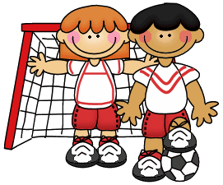

**Fourth Grade**

**Ms. Hays & Ms. Smith**

**September 25, 2015**

[hayst@duvalschools.org](mailto:hayst@duvalschools.org) [stackelbej@duvalschools.org](mailto:stackelbej@duvalschools.org)

(904) 538-0238

Ext: 1205 for Hays

Ext: 1204 for Smith

Get your latest All Star Stats right here monthly.

**ELA/Social Studies**

Reading- We are continuing to read the novel, *Love That Dog* by Sharon Creed. Students will continue to participate in Close Reading Discussions, keep adding to their summary statements, and read a variety of poems to practice analyzing the elements of poetry. Students are learning to LOVE poetry, and have enjoyed creating some of their own poems! ☺

Writing- For writing, students will continue to participate in shared writing activities to help them build well-organized, quality paragraphs. The next set of lessons are focused around organization. Students will write an informative paragraph that summarizes the first half of Love That Dog. They will also learn how to develop the body of an essay, how to use transitional words/phrases, and learn how to use good leads and endings.

**Reminder**

**Please keep in mind that with this new curriculum it is difficult for absent students to make up missed classwork. These lessons are LIVE and move along at a quick rate, therefore making it challenging for students who are frequently absent to stay caught up.**

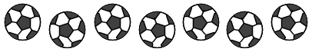

Upcoming Events:

* 9/28 Progress Reports
* 10/1 McTeacher night 5-7pm
* 10/5 Flu Mist 8:40-10:50
* 10/7 Early Release
* 10/15 SAC 6:30-7:30pm
* 10/19-23 Week without Violence
* 10/21 Early Release
* 10/22 Boosterthon Fun Run
* 10/23 Book Fair starts
* 10/26-30 Red Ribbon Week
* 10/26 End of 9 weeks
* 10/29 Fall Festival
* 10/30 No School
* 11/2-5 Vision Screenings
* 11/3 Report Cards go home
* 11/4 Early Release
* 11/4 Fall Photos
* 11/6 Flag Raising

**Math & Science:**

Math- In math we are learning about comparing numbers using the greater-than (>), less-than (<), and equal to (=) symbols. We are also working on rounding multi-digit numbers using various methods.

Science- In science we are talking about the scientific method. We will be digging deeper into each step. Focusing on the different aspects that each step has to offer and how important it is in the scientific method overall.





