

**Fourth Grade**

**Ms. Hays & Ms. Smith**

[hayst@duvalschools.org](mailto:hayst@duvalschools.org) [stackelbej@duvalschools.org](mailto:stackelbej@duvalschools.org)

(904) 538-0238

Ext: 1205 for Hays

Ext: 1204 for Smith

Get your latest All Star Stats right here monthly.



**ELA/Social Studies**

.

Reading- We are currently reading the novel, *Love That Dog* by Sharon Creed. Students are learning about the different elements of poetry, while working through our new Duval Reads Curriculum. Students are participating in “Close Read” Activities, and learning the strategies to become deeper thinkers and fluent readers by using text-based evidence to support their thinking.

In addition, we are continuing to practice our rituals and routines for centers, and going to the computer lab every Thursday and Friday to work on Achieve3000. Parent Reports will be going home Monday!

Writing- Brainstorming ideas for writing, narrowing the focus, and learning about the elements of informational/explanatory writing

**Reminder**

**Please send your child to school with a healthy snack. This is a mid-morning snack so items that are high in sugar will make them crash later. ☺**



Upcoming Events:

* 9/7 No School- Labor Day
* 9/9 Early Release
* 9/10 Open House 6:30-8:00
* 9/11 Flag Raising 8:30am
* 9/15 Volunteer Orientation 9am AND 6:30pm
* 9/17 Boy Scouts sign up 6-8pm
* 9/23 Early Release
* 9/23 Progress Reports Go Home
* 9/24-9/25 Woody’s BBQ Fun Night 6pm
* 10/1 McDonald’s Teacher Night 5-7pm
* 10/5 Flu Mist 8:40-10:50am
* 10/7 Early Release

**Math & Science:**

Math- In math we are learning about place value. We are really focusing on multiplying and dividing by 10 with emphasis on regrouping.

Science- In science we are talking about the scientific inquiry. We have done an experiment mainly focusing on the scientific method and how it is used.

[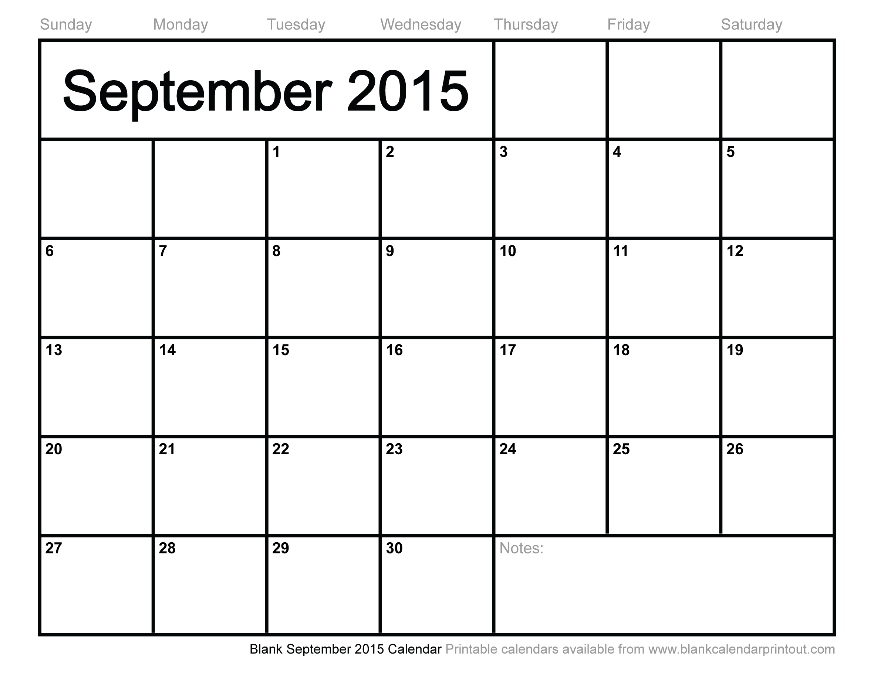](http://www.google.com/url?sa=i&rct=j&q=&esrc=s&frm=1&source=images&cd=&cad=rja&uact=8&ved=0CAcQjRxqFQoTCKuw9_Pm7McCFcfMgAodyi4Kxw&url=http://www.printablecalendar2015x.com/&psig=AFQjCNHeqa8XaLypuUqLLYWLkGTo2Ypbrg&ust=1441986076729259).



**Ms. Hays’ Class website:**

**hays.educatorpages.com**